A

PROJECT REPORT ON

**AN ANDROID APPLICATION FOR EXPENSE MANAGEMENT**

**By**

**SMIT HAPANI (CE-41) (17CEUOS005) RUTWIK KIKANI (CE-62) (17CEUOS068)**

**B.Tech CE Semester-VI Subject: System Design Practice**

**Guided by:** Prof.Pandav K. Patel Assistant Professor Dept. of Comp. Engg.



**Faculty of Technology Department of Computer Engineering**

**Dharmsinh Desai University**



**Faculty of Technology**

**Department of Computer Engineering**

**Dharmsinh Desai University**

## CERTIFICATE

This is to certify that the practical / term work carried out in the subject of

**System Design Practice** and recorded in this journal is the bonafide work of

**SMIT HAPANI (CE-41) (17CEUOS005) RUTWIK KIKANI (CE-62) (17CEUOS068)**

of B.Tech semester **VI** in the branch of **Computer Engineering**

during the academic year **2019-2020**.

Prof. Pandav K. Patel Dr. C. K. Bhensdadia,

Assistant Professor, Head Of Department,

Dept. of Computer Engineering., Dept. of Computer Engineering.,

Faculty of Technology Faculty of Technology

Dharmsinh Desai University, Nadiad Dharmsinh Desai University, Nadiad

|  |  |  |
| --- | --- | --- |
| **No.** | **Contents** | **Page no.** |
| 1 | Introduction | 1 |
| 2 | Software Requirement Specifications | 2 |
| 3 | Design | 5 |
| 4 | Implementation Detail | 12 |
| 5 | Testing & Screen-shots | 13 |
| 6 | Conclusion | 24 |
| 7 | Limitation and Future Extension | 25 |
| 8 | Bibliography | 26 |

# Abstract

Now a days there is everything on internet. People usually want to save the expense so that they can’t forget it. So, we have developed an android application for Expense management. User can add the expense in the application wherever he/she spent the money. They will have different options for choosing categories for the particular expense. So, user can see all the expenses on just click and can see category wise summary for the expenses.

# Introduction

The objective of the project is to develop a system that automates the process and activities of Expense Management. The purpose of the system is to provide basic facility for adding, updating and viewing the expense summary.

User can Add & Update category wise expense. User can see the list of expenses in the decreasing order of date. He/She can also see the summary where he/she spent the money and can back up expense list as PDF file.

#### Technology used:

* Java
* SqlLite Database

#### Platform used:

* Android Studio

# Software Requirement Specification

## End User:

##### R1 - Add Expense

Description: In this, user can add expense details and amount.

R1.1 Select Category

Input: Select category from the list. Output:Category selected.

R1.2 Enter Subject

Input: User will have to enter the subject details. Output: Subject name.

R1.3 Enter date.

Input: Double tap to select a date. Output: Selected date.

Exception:If date is invalid,then exception msg will be shown.

##### R2 – Update Expense

Description: User can update expense details if required.

Input: Update detail which you required. Output: Updated expense.

##### R3 – Delete Expense

Description: User can delete expense details if required.

Input: Delete expense which you required. Output:Expense deleted .

##### R4 – View Expense list

Description: User can view expense details if required.

Input: Show expense list . Output:Expense list.

##### R5 – View Expense summary

Description: User can view expense summary if required.

Input: Show expense summary . Output:Expense summary in percentage.

##### R6 – Make PDF file

Description: User can store expense list as PDF file Input: Convert to PDF.

Output:PDF will be stored in external storage.

# Design

## Use case Diagram

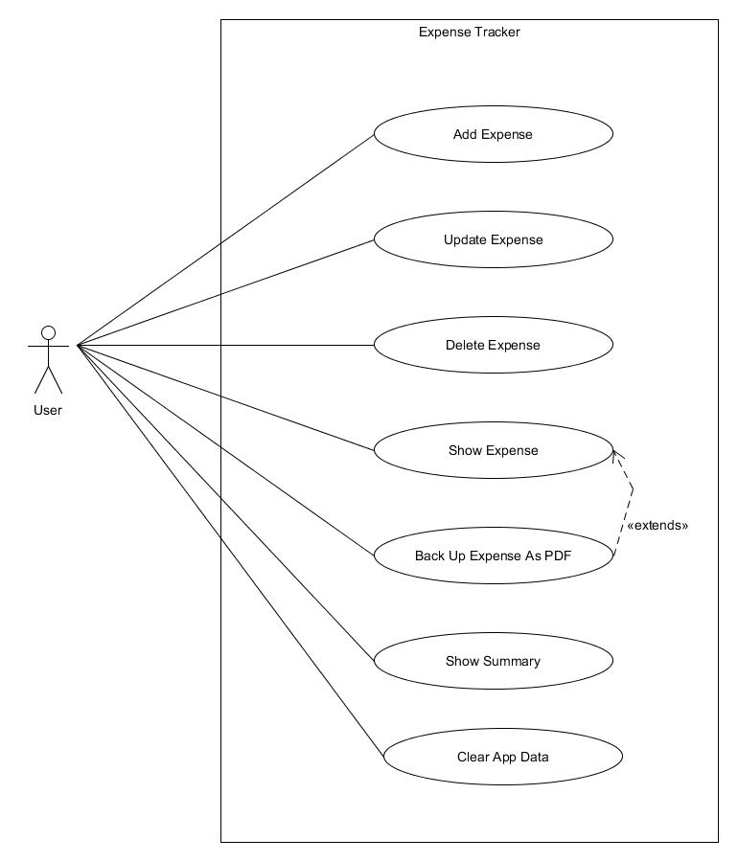

* 1. **ER Diagram**

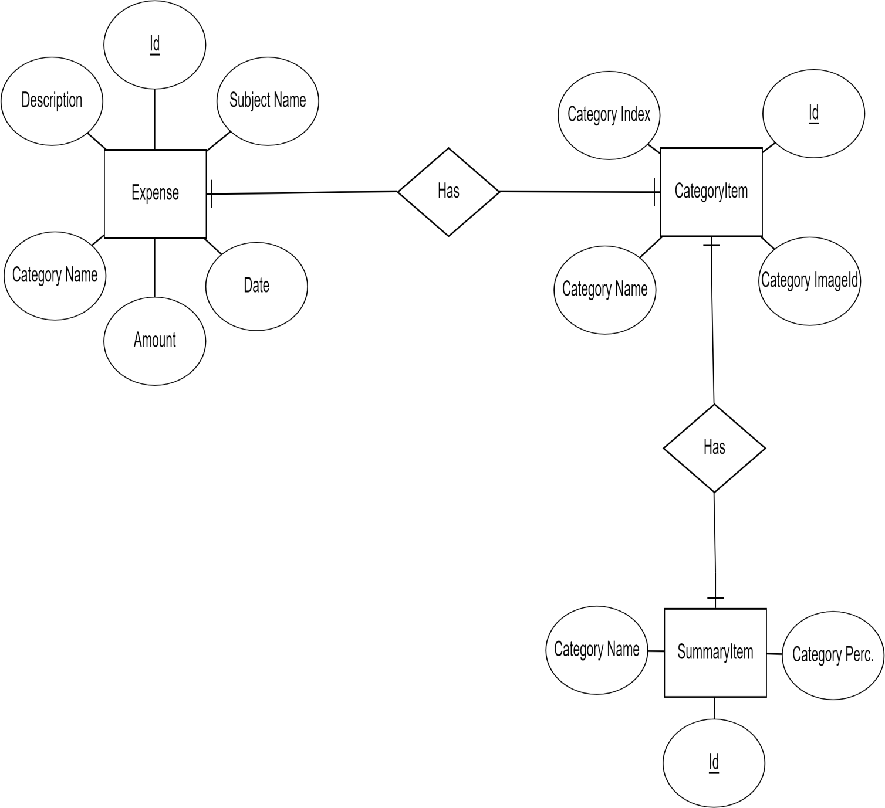

* 1. **Class Diagram**

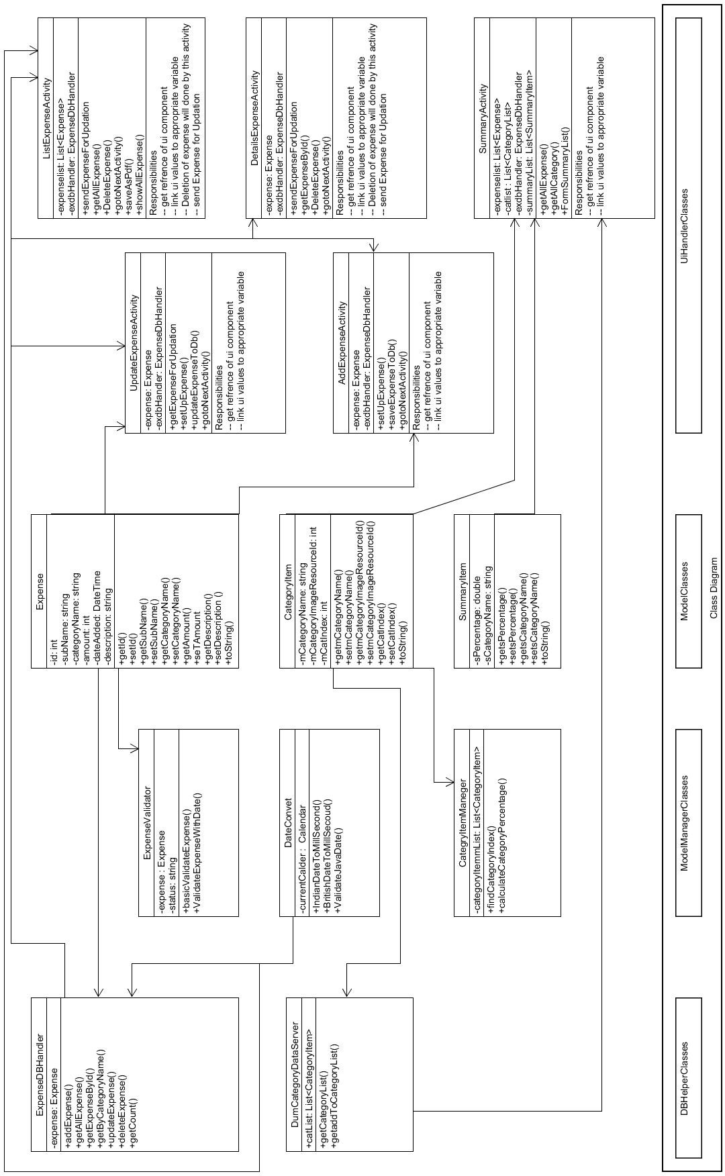

* 1. **Activity Diagram**

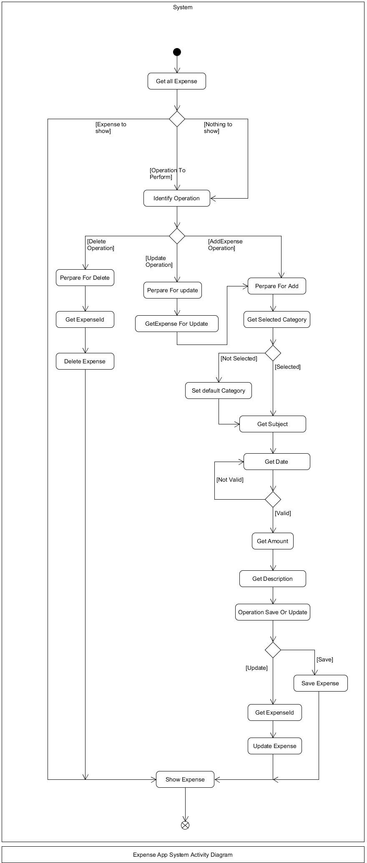

* 1. **Sequence Diagram**

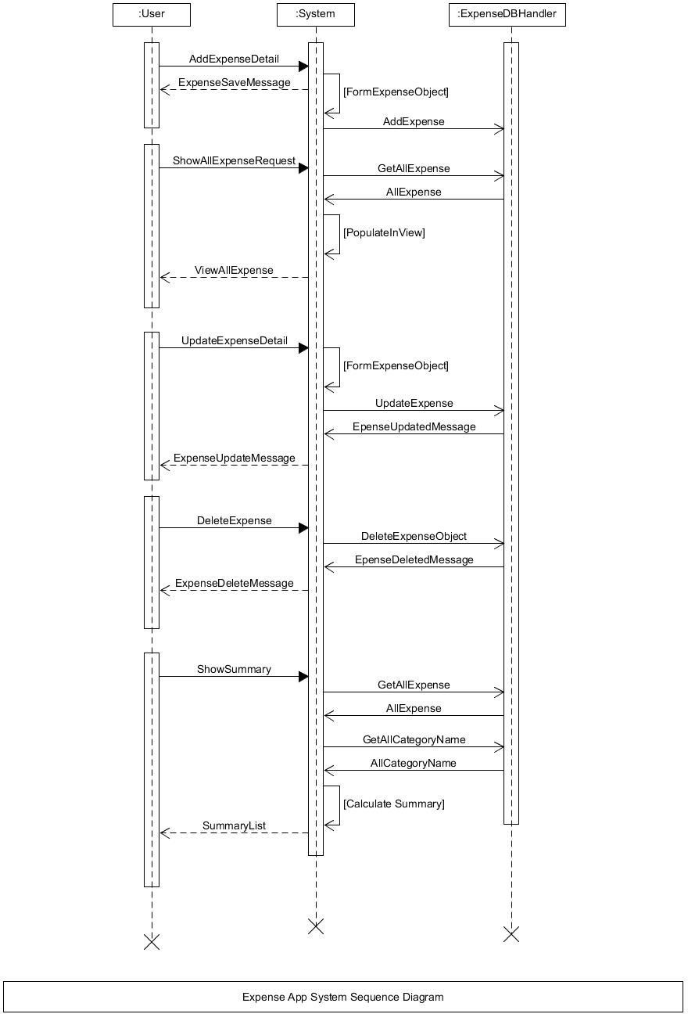

* 1. **DTD:**

|  |  |  |  |  |  |  |  |  |
| --- | --- | --- | --- | --- | --- | --- | --- | --- |
| Expense | | | | | | | | |
| Sr.  No. | Field Name | Data Type | Width | Required | Unique | PK/FK | Referenced Table | Description |
| 1 | Id | Number | 10 | Yes | Yes | PK |  | Primary Key for the  Expense table |
| 2 | Subject Name | Varchar2 | 50 | Yes |  |  |  | Subject of Expense |
| 3 | Date | Date Time |  | Yes |  |  |  | By default, current Date Is provided User can change it also. |
| 4 | Amount | Number | 10 | Yes | Yes |  |  | Amount for the expense. |
| 5 | Category Name | Varchar2 | 10 | Yes | Yes |  |  | Category Name select from drop – down list. |
| 6 | Description | Varchar2 | 50 | No |  |  |  | User can add short  description of expense. |

|  |  |  |  |  |  |  |  |  |
| --- | --- | --- | --- | --- | --- | --- | --- | --- |
| Category Item | | | | | | | | |
| Sr.  No. | Field Name | Data Type | Width | Required | Unique | PK/FK | Referenced Table | Description |
| 1 | Category Name | Varchar2 | 10 | Yes | Yes | PK |  | Category Name is primary key for category table. |
| 2 | Category Image Resource Id | Number | 10 | Yes |  |  |  | Id number for Image Resource of Category |
| 3 | Category Index | Number | 10 | Yes |  |  |  | Index number for displaying category list in dropdown list |

|  |  |  |  |  |  |  |  |  |
| --- | --- | --- | --- | --- | --- | --- | --- | --- |
| Summary Item | | | | | | | | |
| Sr.  No. | Field Name | Data Type | Width | Required | Unique | PK/FK | Referenced Table | Description |
| 1 | Category Name | Varchar2 | 10 | Yes | Yes |  |  | Category Name is for calculate summary for that  category. |
| 2 | Percentage | Number | 10 | Yes |  |  |  | Represent percentage of category. |

Implementation detail

##### Expense Module:

In the home page,there is shown Show Expense and Add expense button. By which, User and show the expense history and add new expense respectively. User can also update the expense details and delete specific expense.

##### Summary Module:

In Summary module, User can see category wise expense summary in percentage also. So, user can keep track of his/her expenses like where he/she spend more money.

# Testing & Screen shots

* Test table

|  |  |  |  |  |
| --- | --- | --- | --- | --- |
| **No.** | **Test Scenarios** | **Expected Result** | **Actual Result** | **Pass/Fail** |
| 1. | While entering Expense by default  first category of expense selected. | Food (first category name) selected toast appear | Food(first category name) selected toast  appear | Pass |
| 2. | Try to save or update Expense without inserting subject | Enter required field error message should be display | “enter required field ”  toast message appear | Pass |
| 3. | Try to save or update Expense without providing date | Enter required field  error message should be display | “enter required field “  toast message appear | Pass |
| 4. | Try to save or update Expense without  providing amount in integer | Enter required filed  error message should be display | “enter required filed”  toast message appear | Pass |
| 5. | Try to save or update Expense without  providing description | Expense should be saved | “Save !!” toast message appear | Pass |
| 6. | Try to save Expense with date in dd/MM/yyyy format | Expense should be saved | “Save !!” toast message appear | Pass |
| 7. | Try to save Expense with date which is future date | Date invalid message should be display | “Date invalid”toast message appear | Pass |
| 8. | Try to save Expense with date in  {0}*dd/{0}*MM/{0}*yyyy format | Expense should be save | “Save !!” toast message appear | Pass |
| 9. | Save Expense list without permission of storage | Permission denied message should be display | “Permission Deny” toast appear | Pass |
| 10. | Save Expense list with permission of storage | Appropriate message should be display | “Permission already granted” & “(file name) Save !!” toast appear | Pass |
| 11. | Try to save empty Expense list in storage with storage permission | Appropriate message should be display | Only “Permission already granted ” toast message appear | Pass |
| 12. | While trying to update any Expense which is already save. | All input field should be filled appropriate values | All input field filled with appropriate values | Pass |

* Screen shots

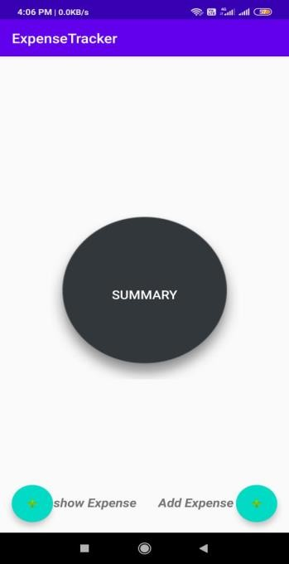 (Home page)

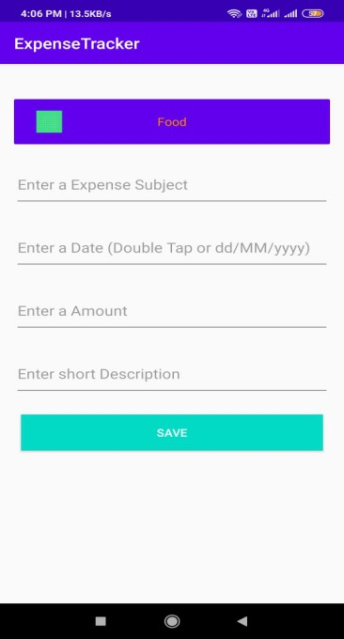(Add Expense)

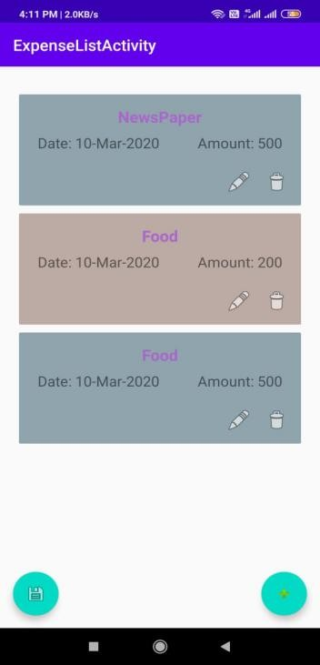(Expense list)

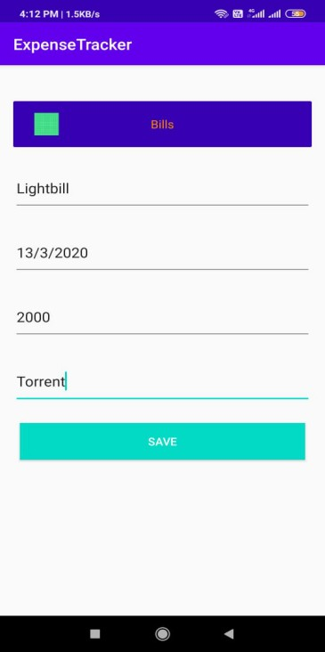(Adding the expense)

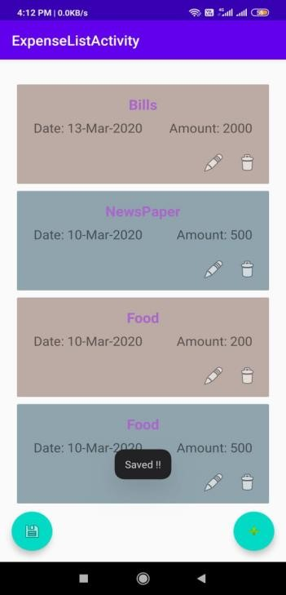(Expense Added)

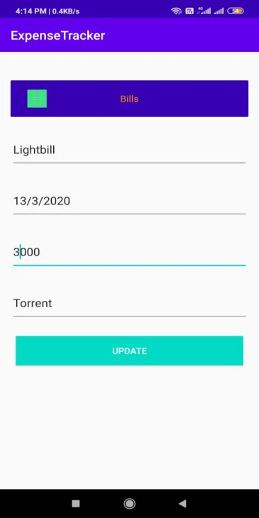(Updating expense)

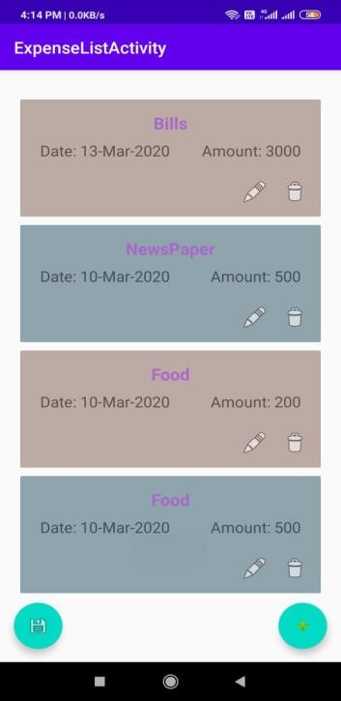(Updated Expense list)

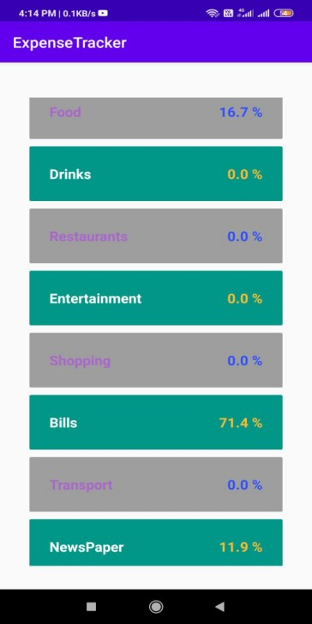(Summary)

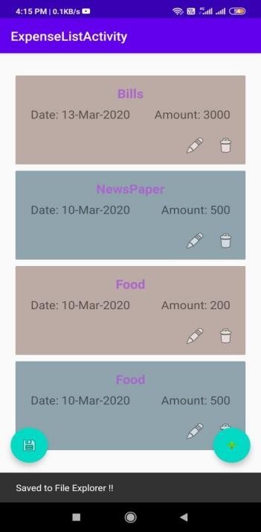(Save as PDF)

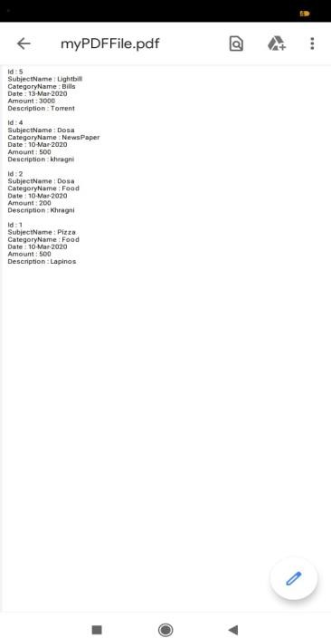

(PDF view of expense)

# Conclusion

In this project we have successfully implemented functionalities like Add expense, Update expense, Delete expense, View Expense-list, View Summary and convert Expense-list to PDF. In our android application, Expense list is shown in the decreasing order of date. We have put date validation in our Expense Tracker application.

# Limitations and Future Extension

### Limitations:

We have not implemented the Custom category functionality. Instead we have provided category list by which user can choose any category. We haven’t put date-wise expense filter. And while inserting a amount of expense it should be integer.

### Future Extension:

* + - Custom Category will be provided.
    - Date-wise filter will be provided.
    - We are looking to implement pi-chart.

# Bibliography

<https://developer.android.com/training/data-storage/sqlite>

<https://developer.android.com/guide/components/intents-filters>

[https://stackoverflow.com/questions/12298835/how-to-retrieve-data-from-](https://stackoverflow.com/questions/12298835/how-to-retrieve-data-from-sqlite-database-in-android-and-display-it-in-textview) [sqlite-database-in-android-and-display-it-in-textview](https://stackoverflow.com/questions/12298835/how-to-retrieve-data-from-sqlite-database-in-android-and-display-it-in-textview)

<https://developer.android.com/reference/android/view/package-summary>